**IPP Show**

**& Expo**



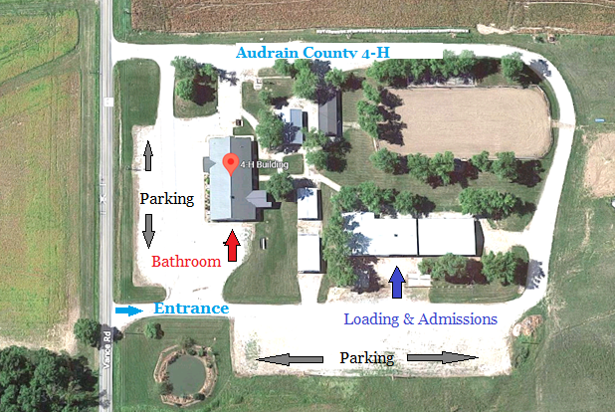

**June**

**16 – 18**

**2023**

**Audrain County 4-H Center** 21509 State Hwy D Mexico, MO